Glutamic acid
Commercially, 90% of the glutamic acid is produced by microbial fermentation and remaining 10% is met through chemical methods. L-glutamic acid was the first amino acid produced commercially.
Raw materials:
The raw materials used include carbohydrate (glucose, molasses, sucrose, etc.), peptone, inorganic salts and biotin.
Biotin concentration in the fermentation medium has a significant influence on the yield of glutamic acid. Fermentation completes within 2-4 days and, at the end of the fermentation, the broth contains glutamic acid in the form of its ammonium salt.
In a typical downstream process, the bacterial cells are separated and the broth is passed through a basic anion exchange resin. Glutamic acid anions get bound to the resin and ammonia is released. This ammonia can be recovered via distillation and reused in the fermentation.
Elution is performed with NaOH to directly form monosodium glutamate (MSG) in the solution and to regenerate the basic anion exchanger. From the elute, MSG may be crystallized directly followed by further conditioning steps like decolourization and serving to yield a food-grade quality of MSG.

Fig;
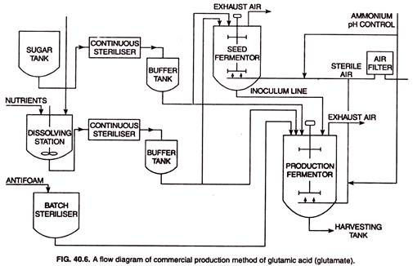
α-ketoglutaric acid serves as the precursor of glutamic acid and the conversion of the α- ketoglutaric acid to glutamic acid occurs in presence of enzyme glutamic acid dehydrogenase. It has been found that if penicillin is added in the medium, the glutamic acid production can be increased manifold.
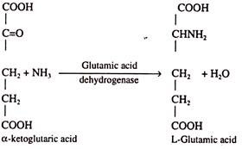

Microorganism: Corynebacteriumglutamicum (C. glutamicum) is one of the major organisms widely used for glutamic acid production.In biotechnological processes, Corynebacterium species are used for economic production of glutamic acid by submerged fermentation.

Some other microorganisms are also used such as

C. lilum

Brevibacterium spp. ( B. divericartum, B. alanicum

Microbacterium spp. (M. flavumvar, glutamicum)

Arthrobacter spp. (A. globiformis, A.aminofaciens)

Uses of Glutamic Acid:
1.Glutamic acid is widely used in the production of monosodium glutamate (MSG) which is commonly known as the ‘seasoning salt’. The world production of glutamic acid is to the tune of 800,000 tonnes/year. Monosodium glutamate is condiment and flavour-enhancing agent, it finds its greatest use as a common ingredient in convenient food-stuffs.
2. GA is imp. In brain metabolism.hence various analouges of GA acid are used in treating various neurophatic diseases.
3. heavy metal absorber.
4. curable biological adhesive.
5. used in cosmetics.

